Balancing Equations worksheet
Example:
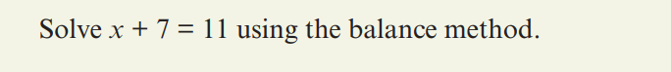
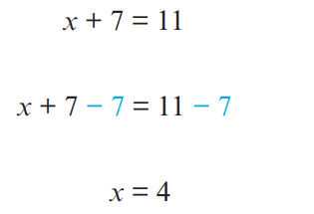
__________________________________________________________________________________

Your turn:
Question 1:
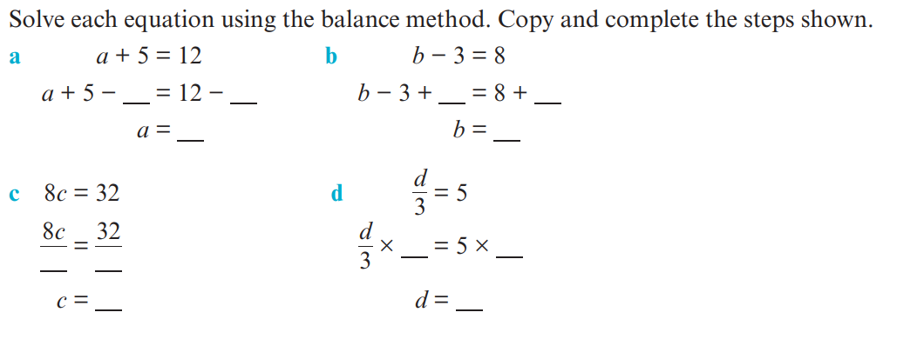Question 2:
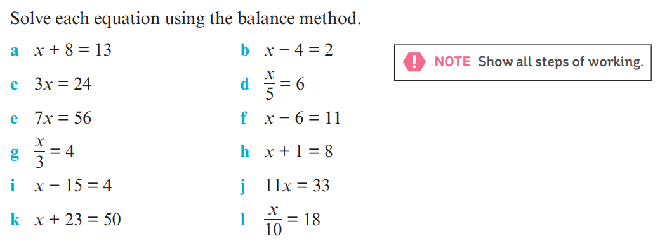
Complete these in your INB

